HTML Editor Guide

what is the html editor and where can i find it?

The HTML Editor is the primary method of creating content in the Learning Environment. It allows users to enter text, pictures, embed audio/video, or even embed HTML code.

html editor interface
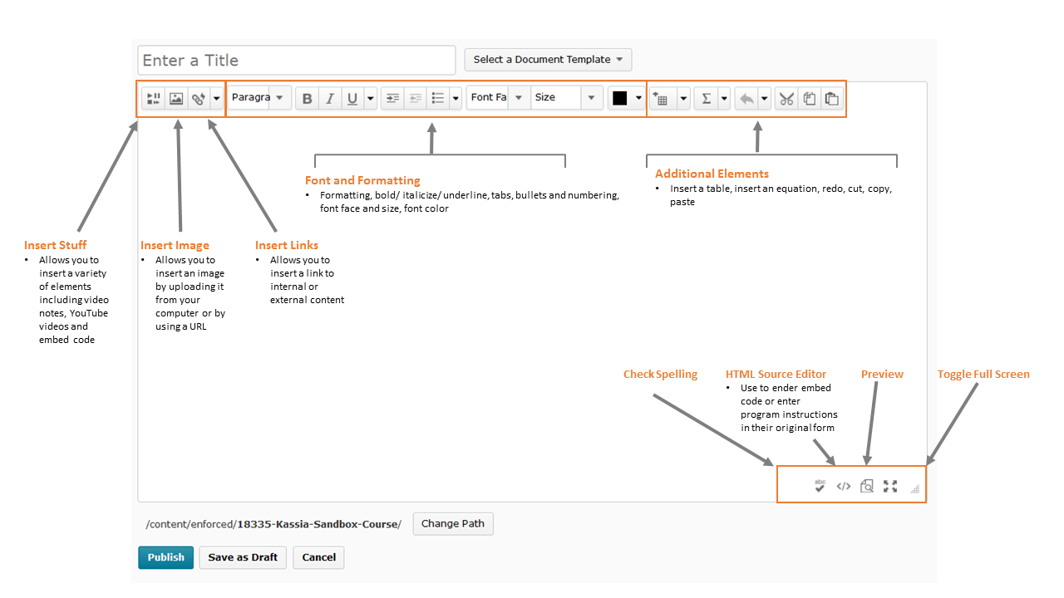

html editor vs word processing
The HTML Editor has many icons that match those of common word processing software: bold, left justify, bullets, and so on. It’s important to remember the HTML Editor is not a word processor. When you add pictures, links or embed videos, you are creating references to items that are stored internally or externally. If those items are changed or deleted, the reference will not display properly.

embedding YouTube™ videos and Flickr® photos

Click Insert Stuff and select either YouTube or Flickr to be taken to a search page for these platforms. Once you’ve found the required media, click Insert (users will have the option to alter the size of Flickr photos before clicking Insert).

using embed code from other sites
Copy the code from the site (CTRL+C). In the Learning Environment, click on Edit HTML Source and paste (CTRL+V) the code into the window provided. If you’ve already entered content, ensure you do not erase or copy over the existing HTML code. Alternatively, paste the embed code into Insert Stuff > Enter Embed Code.
NOTE: If embedded content is deleted or altered on the source site, the link created in the Learning Environment will reflect that change.

inserting pictures
When you click the Insert Picture icon , you can insert pictures from one of four sources:
My Computer: Browse your computer/network for a picture and upload it to the Learning Environment. This will simultaneously upload and store the file on the Learning Environment and create a reference within the HTML editor.
Course Offering Files: Select from pictures that have already been uploaded to your course files in the Learning Environment.
Shared Files: Search files that have been shared from other org units within the Learning Environment.
URL: If the image has a URL, create a reference with this option.

INSERTING LINKS
You can create an immediate link to many tools within the Learning Environment (Quizzes, Surveys, etc.). Simply select the tool and you will be prompted to select an existing item or create a new one. You can also link to external sites by selecting URL.
NOTE: If the embedded content is deleted or altered on the source site, the link created in the LE will reflect that change. D2L is not responsible for content linked from third-party sites.

administrating the html editor
The HTML Editor configuration variables can be found in the Admin tool Config Variable Browser All Tools WYSIWIG. This is a common acronym meaning “What You See Is What You Get”.
The following variables can be altered:
- Users’ ability to edit the HTML source
- Object code item source is displayed is available on item source list in Insert Stuff
- URL item source is displayed is available on item source list in Insert Stuff
Configuration variables are set by administrators and are not generally alterable by instructors. If you are an instructor and do not have access to something you should, contact your administrator.

what tools USE THE HTML EDITOR?
You will find the HTML Editor throughout the Learning Environment. Some common areas of use are:

want more informatioN?
Visit the Brightspace Community (https://community.brightspace.com) or D2L Resource Centre (https://documentation.desire2learn.com) for videos, documents and other resources.
About D2L

A global leader in EdTech, D2L is the creator of Brightspace, the world’s first integrated learning platform. The company partners with thought-leading organizations to improve learning through data-driven technology that helps deliver a personalized experience to every learner, regardless of geography or ability. D2L’s open and extensible platform is used by more than 1,100 clients and 13 million individual learners in higher education, K–12, healthcare, government, and the enterprise sector—including Fortune 1000 companies.
The company has operations in the United States, Canada, Europe, Australia, Brazil, and Singapore.
© 2014 D2L Corporation.
The D2L family of companies includes D2L Corporation, D2L Ltd, D2L Australia Pty Ltd, D2L Europe Ltd, D2L Asia Pte Ltd, and D2L Brasil Soluções de Tecnologia para Educação Ltda.
Brightspace, D2L, and other marks (“D2L marks”) are trademarks of D2L Corporation, registered in the U.S. and other countries. Please visit D2L.com/trademarks for a list of other D2L marks.

